**Atomic Energy Central School, Narora**

***Prepared by - Shuchita Singh***

***Class - IX-B***

***Roll no.-23***

**Academic year-2017-18**

**Guided by: Ashoka Rao Sir**

**Computer Science Project**

<HTML>

<HEAD>

<TITLE>HOME PAGE</TITLE></HEAD>

<BODY BACKGROUND="BACKGROUND.JPG" LINK="800080" VLINK="PURPLE" ALINK="BLUE" TOPMARGIN="10" LEFTMARGIN="10">

<COMMENT>This is the main web page. Other web pages are linked to it from images.</COMMENT>

<FONT FACE="Felix Titling" COLOR="#5F04B4" SIZE="6">Home Page</FONT>

<FONT face="Gisha">

<HR color="#8000FF">

<FONT FACE="Californian FB" COLOR="#0000FF" SIZE="7">Robots that are changing the world</FONT>

<BIG>

<P>A <B>robot</B> is a machine—especially one programmable by a computer— capable of carrying out a complex series of actions automatically. Robots can be guided by an external control device or the control may be embedded within. Robots may be constructed to take on human form but most robots are machines designed to perform a task with no regard to how they look.</P>

<P>Robotics, Design, construction, and use of machines (robots) to perform tasks done traditionally by human beings. Robots are widely used in such industries as automobile manufacture to perform simple repetitive tasks, and in industries where work must be performed in environments hazardous to humans. Many aspects of robotics involve <B>Artificial Intelligence (AI)</B>; robots may be equipped with the equivalent of human senses such as vision, touch, and the ability to sense temperature. Some are even capable of simple decision making, and current robotics research is geared toward devising robots with a degree

of self-sufficiency that will permit mobility and decision-making in an unstructured environment. Today’s industrial robots do not resemble human beings; a robot in human form is called an <B>Android</B>.</P>

<P>Whether they're taking our jobs, acting as our personal butlers or planning mankind's robopocalypse downfall, we've been obsessed with robots for centuries. What's surprising is Hanson Robotics' <B>Sophia - a robot - was even granted citizenship</B> in Saudi Arabia recetly. While Sophia is the first to get this distinction, here are few more of her kind that are set to change the way we live, work and love:</P>

<MARQUEE>

<A HREF="Sophia.html"><IMG src="Sophia.jpg" HEIGHT="175" WIDTH="235" ALT="Sophia"></A>

<A HREF="Reem.html"><IMG src="Reem.jpg" HEIGHT="220" WIDTH="145" ALT="Reem"></A>

<A href="Harry.html"><IMG src="Harry.jpeg" HEIGHT="195" WIDTH="320" ALT="Harry"></A>

<A HREF="Kaspar.html"><IMG src="Kaspar.jpg" HEIGHT="225" WIDTH="150" ALT="Kaspar"></A>

<A href="YuMi.html"><IMG src="YuMi.jpg" HEIGHT="165" WIDTH="225" ALT="YuMi"></A>

<A href="Komodoroid.html"><IMG src="Kodomoroid.jpg" HEIGHT="220" WIDTH="145" ALT="Kodomoroid"></A>

<A HREF="ASIMO.html"><IMG src="ASIMO.jpg" HEIGHT="196" WIDTH="145" ALT="ASIMO"></A>

</MARQUEE>

</BIG>

</FONT>

</BODY>

</HTML>

<HTML>

<HEAD><TITLE>SOPHIA</TITLE></HEAD>

<BODY BACKGROUND="SophiaBaG.jpg" TOPMARGIN="50"

LEFTMARGIN="50">

<!-This is the first webpage that has been linked.->

<FONT face="Candara" size="5">

<CENTER><FONT COLOR="#2ECCFA" face="Colonna MT"

size="7"><H1>Sophia</H1>

</FONT></CENTER>

Sophia is a social humanoid robot developed by Hong Kong-based company <b>Hanson Robotics</b>. Sophia was activated on <b>April 19, 2015</b> and made her first public appearance at South by Southwest Festival (SXSW) in mid-March 2016 in Austin, Texas, United States. She is able to display more than 62 facial expressions. She has a procelain skin, a slender nose, an intriduing smile, and eyes that seen to change colour with the light. Sophia has been covered by media around the globe and has participated in many high-profile interviews. While interviewers around the world have been impressed by the sophistication of many of Sophia's responses to their questions, the bulk of Sophia's meaningful statements are believed by experts to be somewhat scripted.

<br><br>

<CENTER><IMG src="Sophia3.jpg" height="300" width="300">

<IMG src="Sophia2.jpg" height="250" width="400">

<IMG src="Sophia4.jpg" height="300" width="275"></CENTER>

</FONT>

</BODY>

</HTML>

<HTML>

<HEAD><TITLE>Reem</TITLE></HEAD>

<BODY BACKGROUND="ReemBg.jpg" TOPMARGIN="50"

LEFTMARGIN="50">

<!-This is the second webpage that has been linked.->

<FONT SIZE="5" FACE="Candara">

<FONT COLOR="#380B61" FACE="Imprint MT Shadow" SIZE="6"><H1>Reem: Service Robot</H1></FONT>

<p>Spanish robot Reem is a service robot, intended for exibition spaces, events and promotions. It can be programmed to offer directions, greet guests or act as a emcee. It can move around, and interact with the public through commands issued through its chest-mounted touchscreen. REEM is the latest prototype humanoid robot built by <b>PAL Robotics</b> in Spain. It is a 1.70 m high humanoid robot with 22 degrees of freedom, with a mobile base with wheels, allowing it to ove at 4 km/hour. The upper part of the robot consists of a torso with a touch screen, two motorized arms, which give it a high degree of expression, and a head, which is also motorized. <b>REEM-A</b> and <b>REEM-B</b> are the first and second prototypes of humanoid robots created by PAL Robotics. REEM-B can recognize, grasp and lift objects and walk by itself, avoiding obstacles through simultaneous localization and mapping. The robot accepts voice commands and can recognize faces.</p>

<CENTER>

<IMG src="Reem2.jpg" height="350" width="850" alt="Reem">

</CENTER>

</font>

</BODY>

</HTML>

<HTML>

<HEAD>

<TITLE>Harry</TITLE></HEAD>

<BODY BACKGROUND="HarryBG.JPG" TOPMARGIN="50"

LEFTMARGIN="50">

<!-This is the third webpage that has been linked.->

<FONT SIZE="5" FACE="Lao UI">

<FONT color="#5F04B4" FACE="Imprint MT Shadow" SIZE="6"><H1>HARRY: Trumpet-playing robot</H1></FONT>

Toyota's Harry was built with one purpose in mind: to play the trumpet. And boy, can he toot that horn. Though it could easily cheat with some well hidden speakers, the robot authentically plays the trumpet, pushing the compressed air through flexible lips, and hitting the valves for each note with a methodical accuracy.<br><br>

<CENTER>

<IMG src="Harry2.jpg" height="350" width="400" alt="Harry">

<IMG src="Harry3.jpg" height="300" width="400" alt="Harry">

</CENTER>

</font>

</BODY>

</HTML>

<HTML>

<HEAD><TITLE>Kaspar</TITLE></HEAD>

<BODY BACKGROUND="KasparBg.jpg" TOPMARGIN="50"

LEFTMARGIN="50">

<!-This is the fourth webpage that has been linked.->

<FONT SIZE="5" FACE="Leelawadee">

<FONT COLOR="#DF0174" FACE="ColonnaMT" SIZE="6"><H1>

Kaspar: Expressive Social Robot</H1></FONT>

<p>Kaspar serves a unique and and worthy purpose. It is designed to be used by children who have conditions related to autism, who often find it difficult to read their peer's expressions. The minimal movements of Kaspar encourage children with autism to explore new ways of communicating. Researchers aim to reengineer Kaspar into an advanced and affordable robot available to any child that needs it.</p>

<CENTER>

<IMG src="Kaspar2.jpg" height="350" width="250" alt="Kaspar">

<IMG src="Kaspar3.jpg" height="300" width="400" alt="Kaspar">

</CENTER>

</font>

</BODY>

</HTML>

<HTML>

<HEAD>

<TITLE>YuMi</TITLE></HEAD>

<BODY BACKGROUND="YuMiBG.JPG" TOPMARGIN="50"

LEFTMARGIN="50">

<!-This is the fifth webpage that has been linked.->

<FONT SIZE="6" FACE="Bell MT">

<FONT COLOR="#9A2EFE" FACE="Imprint MT Shadow"

SIZE="6"><H1>YuMi: Dual-Arm collaborative robot</H1></FONT>

When we talk of automation of work forces and potential human job losses as a result, you probably picture something a little like YuMi in your mind. Though its lacking an identifiably human head, its arms are clearly modelled on those of a person. It's certified as safe to work alongside humans thanks to its small size.

<CENTER>

<IMG src="YuMi2.jpg" height="275" width="400" alt="YuMi">

<IMG src="YuMi3.jpg" height="275" width="275" alt="Harry">

</CENTER>

</font>

</BODY>

</HTML>

<HTML>

<HEAD>

<TITLE>Komodoroid</TITLE></HEAD>

<BODY BACKGROUND="KomodoroidBG.JPG" TOPMARGIN="50"

LEFTMARGIN="50">

<!-This is the sixth webpage that has been linked.->

<FONT SIZE="5" FACE="Candara">

<FONT COLOR="#04B4AE" FACE="Colonna MT"

SIZE="6"><H1>Komodoroid: Communication Android</H1></FONT>

At first glance, you'd be forgiven for thinking that Komodoroid was a young girl. One of the realistic androids in the world, Komodoroid acts as a newspaper reader, reading out the latest headlines and moving its body and features realistically in time with its enuciation of each word. <br><br>

<CENTER>

<IMG src="Komodoroid2.jpg" height="300" width="400"

alt="Komodoroid">

<IMG src="Komodoroid3.jpg" height="300" width="200"

alt="Komodoroid">

<IMG src="Komodoroid4.jpg" height="300" width="300"

alt="Komodoroid">

</CENTER>

</font>

</BODY>

</HTML>

<HTML>

<HEAD><TITLE>ASIMO</TITLE></HEAD>

<BODY BACKGROUND="ASIMOBg.jpg" TOPMARGIN="50"

LEFTMARGIN="50">

<!-This is the seventh webpage that has been linked.->

<FONT COLOR="#4000FF" FACE="Imprint MT Shadow"

SIZE="6"><H1>ASIMO: Advanced Mobility Robot</H1></FONT>

<FONT SIZE="6" FACE="Bell MT">

<p>Perhaps the most recognisable real world robot in existense, ASIMO has been wondering crowds around the world since it was first shown off. Moving with presisely applied agility, ASIMO is as close as we have come to the sci-fi vision of a robot companion - even if his social interactions aren't quite as redefined as his dexterous wave and silky strut. ASIMO (whose name comes from English initials or words Advanced Step in Innovative Mobility) is a humanoid robot created by Honda in 2000. It is currently displayed in Miraikan museum in the Japanese capital city of Tokyo.</p>

<CENTER>

<IMG src="ASIMO2.jpg" height="300" width="150" alt="ASIMO">

<IMG src="ASIMO3.jpg" height="300" width="300" alt="ASIMO">

<IMG src="ASIMO4.jpg" height="300" width="200" alt="ASIMO">

</CENTER>

</font>

</BODY>

</HTML>

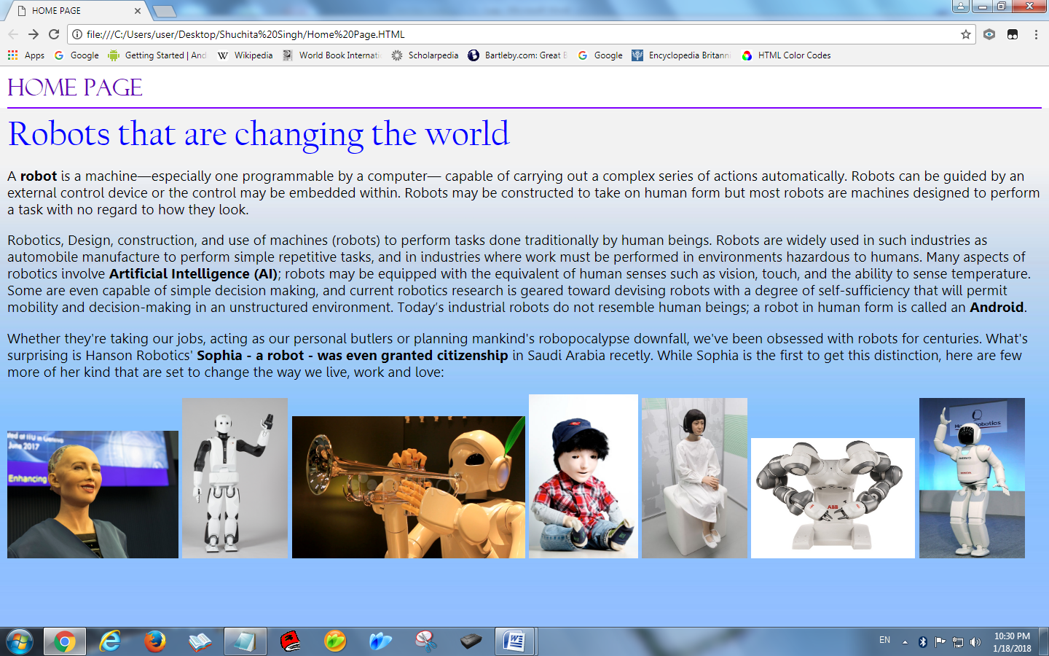

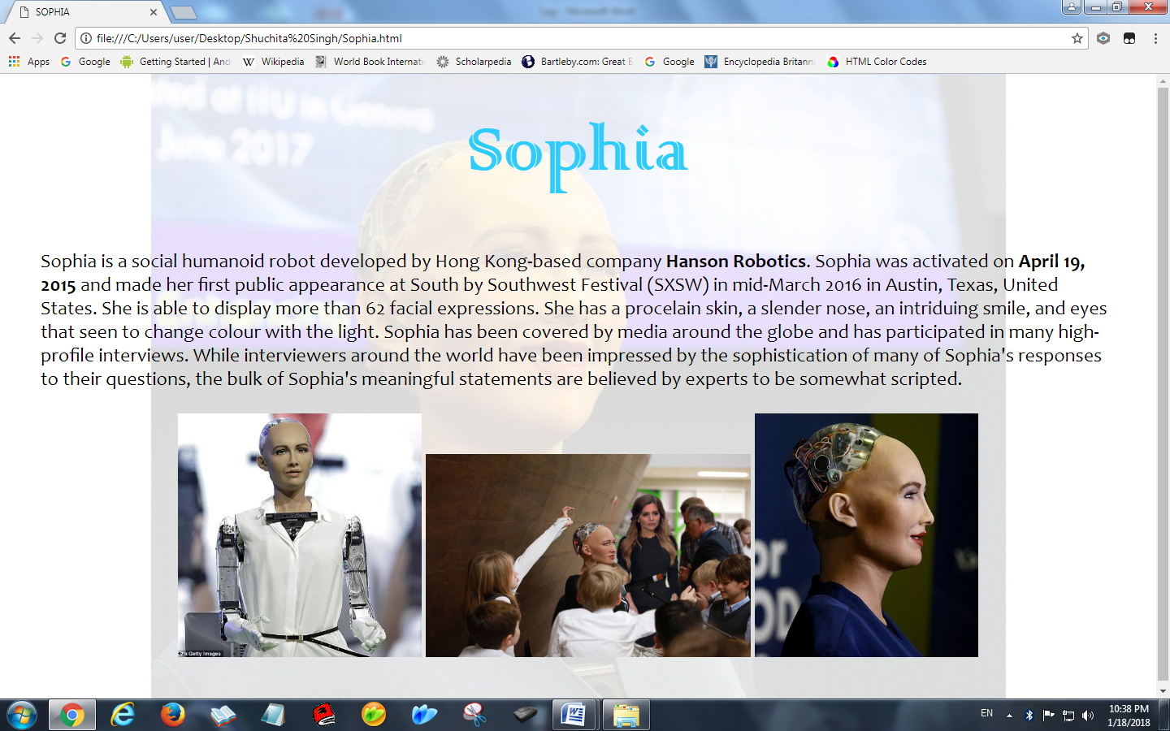f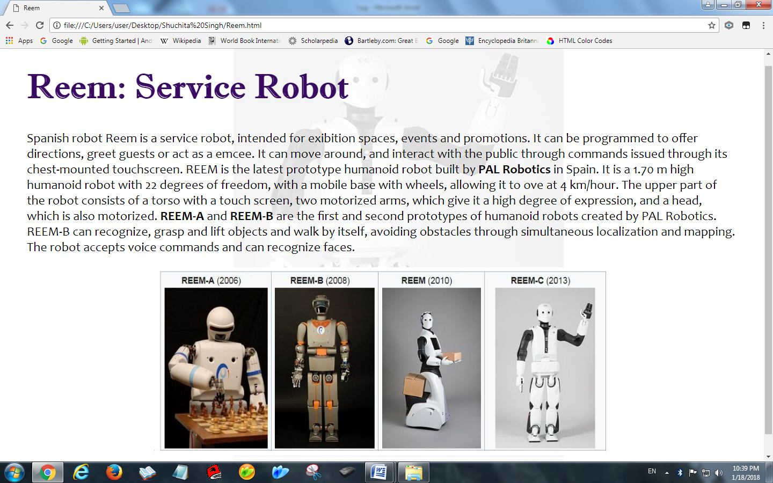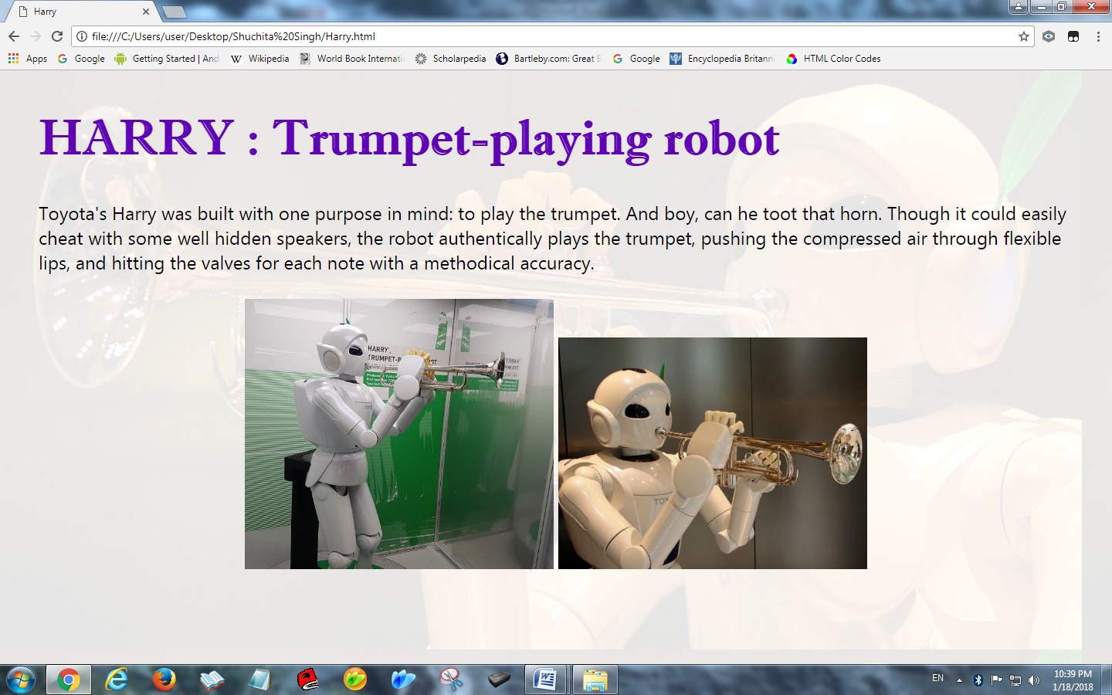k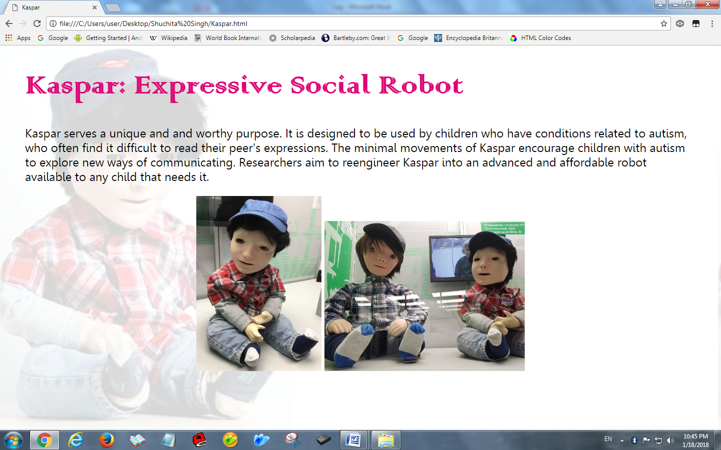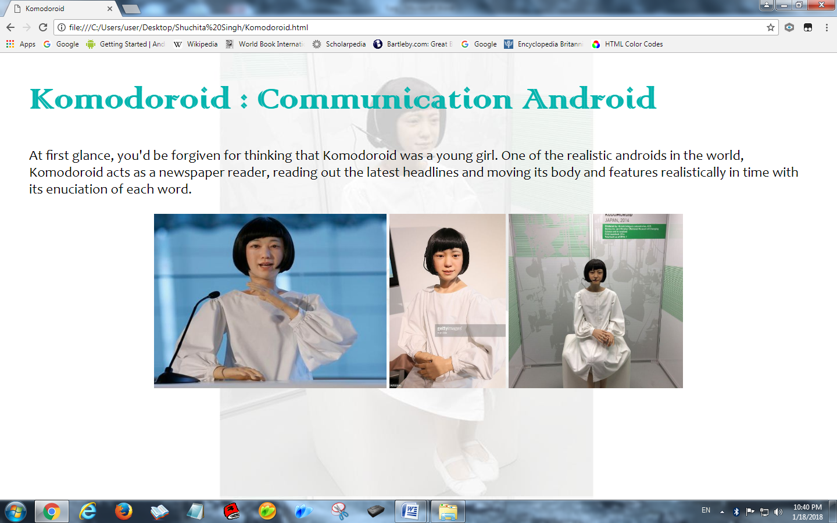s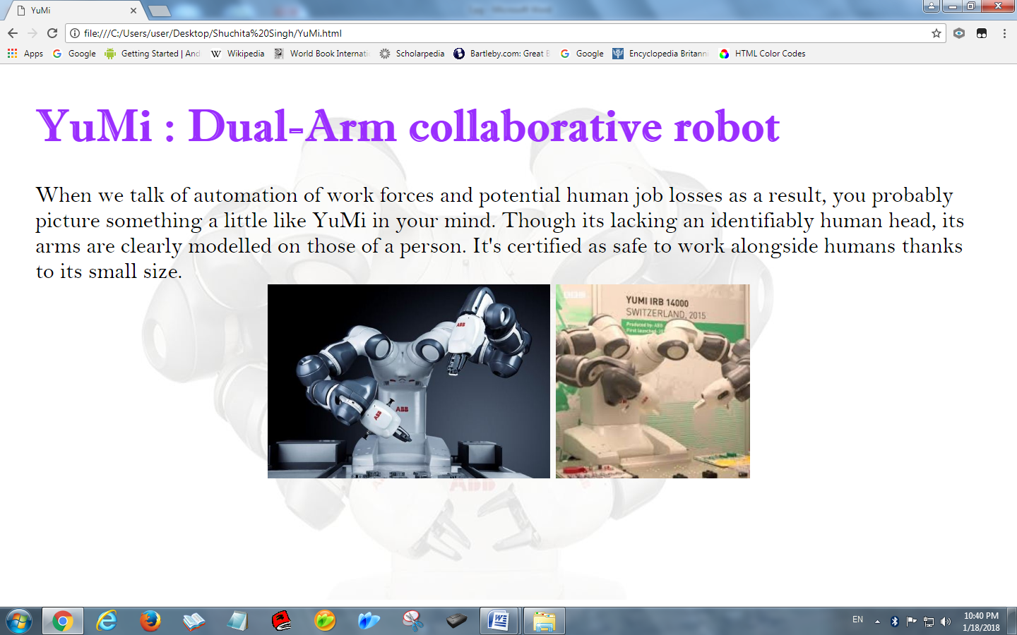s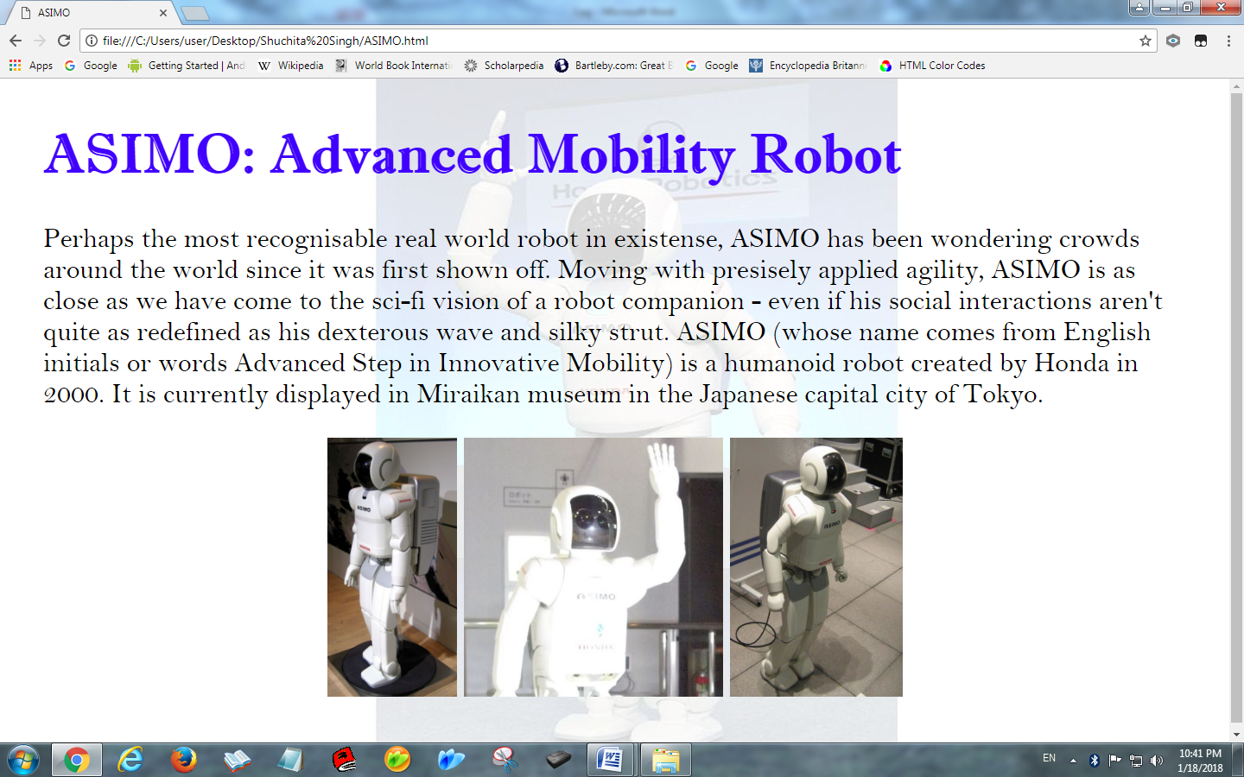

**Prepared by - Shuchita Singh**

**Class - IX-B**

**Roll no.-23**